# Reindeer Exploder

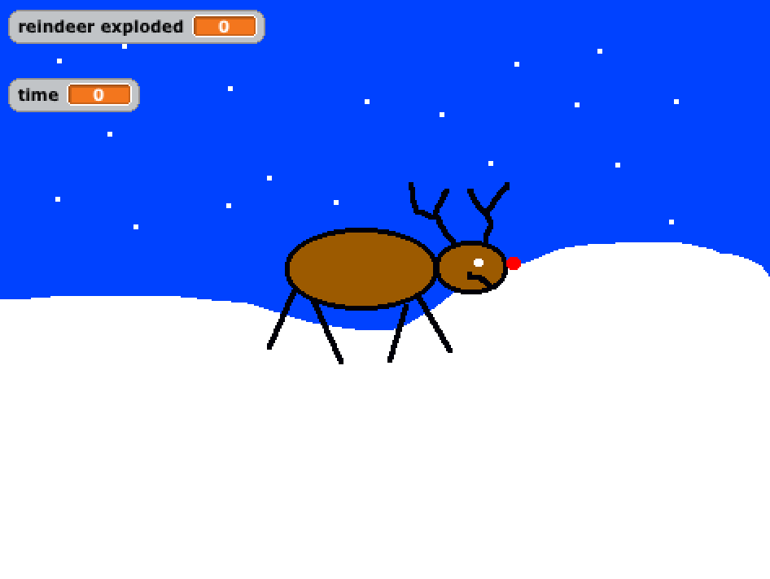

The object of this game is to explode as many reindeer as you can within 10 seconds. Press the space bar to shoot a carrot at the reindeer and make him explode.

Start a new project and delete the cat.

## Background

Draw a snowy background by selecting the background tab and add pressing paint to draw a new background. Delete the old background so the screen looks like this:

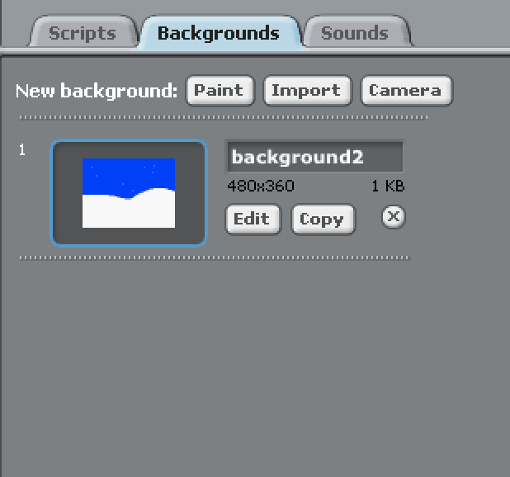

## Sprites

Draw two sprites, a reindeer and a carrot. Name them reindeer and carrot:

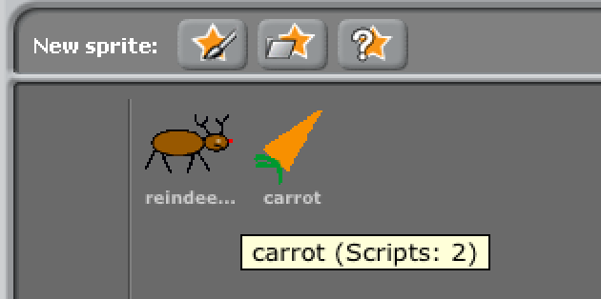

Add two costumes to the reindeer sprite. One called reindeer and one called explode:

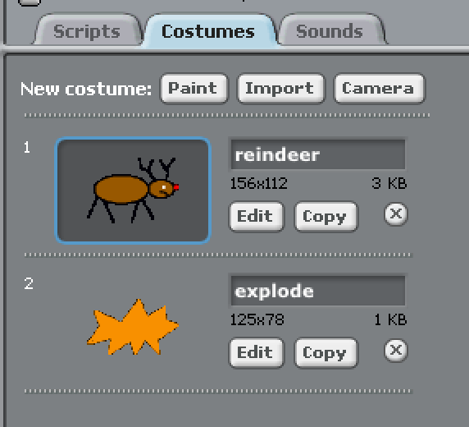

## Variables

You’ll need to add three variables time, count and reindeer exploded. Make sure the count variable isn’t ticked so it doesn’t show on the screen.

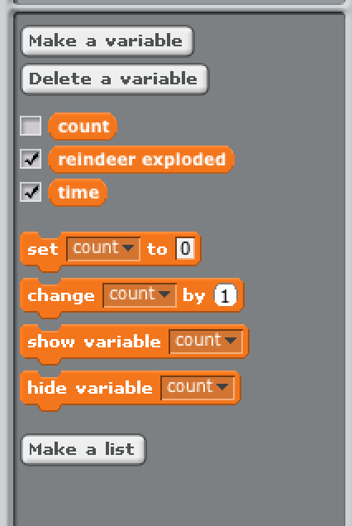

## Scripts

Add the following scripts to the reindeer:

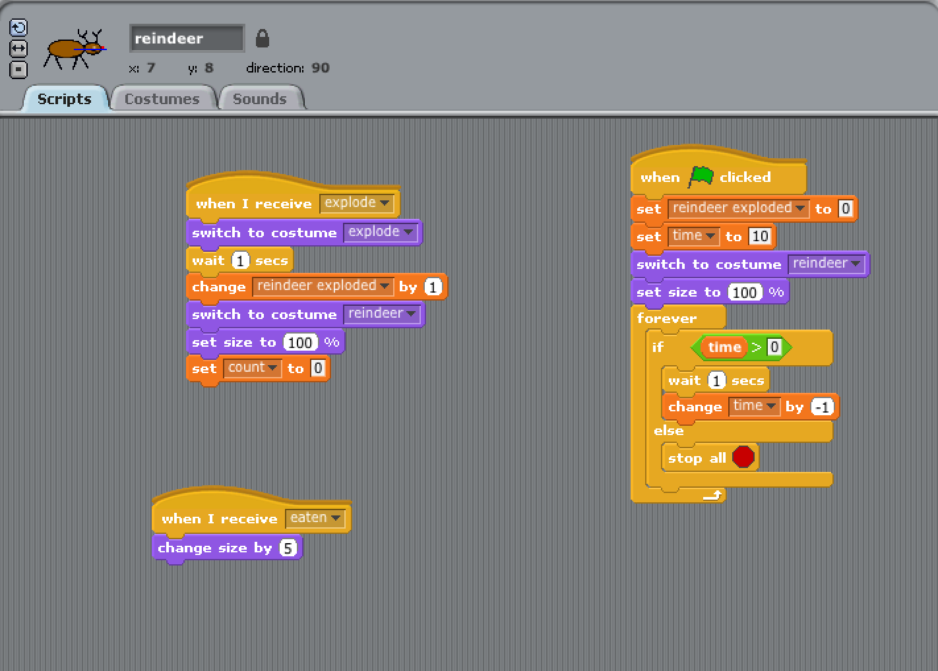

Add the following scripts to the carrot:

